This tip sheet covers your first login to your database.

You should be provided with a user name and password by your PowerBase administrator.

Tip: Be sure never to share a login with another person. Sharing logins makes it harder to secure your database if a password is forgotten or compromised.

Your database web address will contain a variation on your group's name plus .ourpowerbase.net. For example, https://ptp.ourpowerbase.net/. Or, for trainings, https://training1.ourpowerbase.net/.

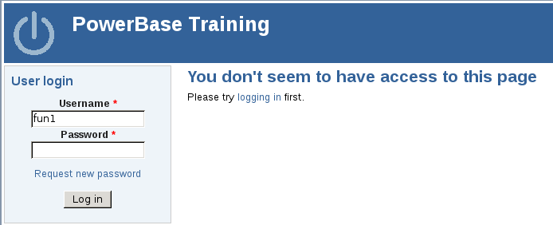
Enter your username and password in the form at the top left.

After successfully logging in, you should see a page like the one below. Click the “My Account” link to change your password.

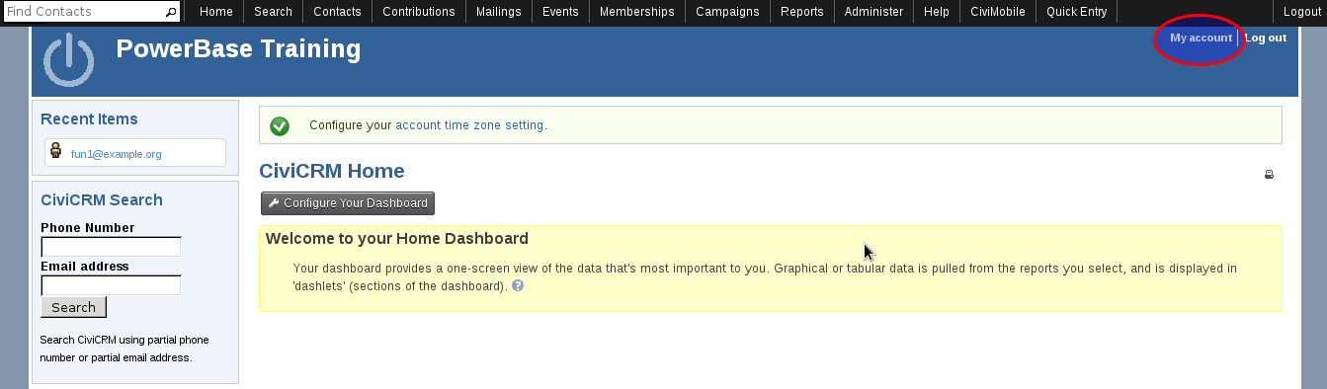

Next, click the Edit link...

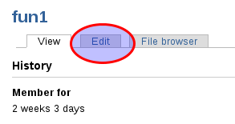
..and fill in both your current password and your new password (twice).
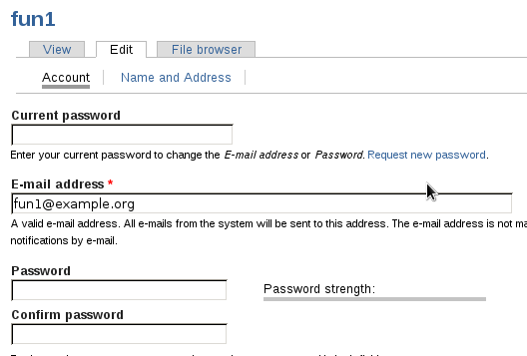

When you are done, scroll to the botton and click the save button.

