When organizing, it's critical to know how your contacts are related. For example, most of us want to know which individuals are working for which organizations. However, depending on your organization needs, you may want more specific relationships, such siblings, children or the congregation a contact belongs to.

PowerBase allows you to track all of these relationships using the Relationships tag.
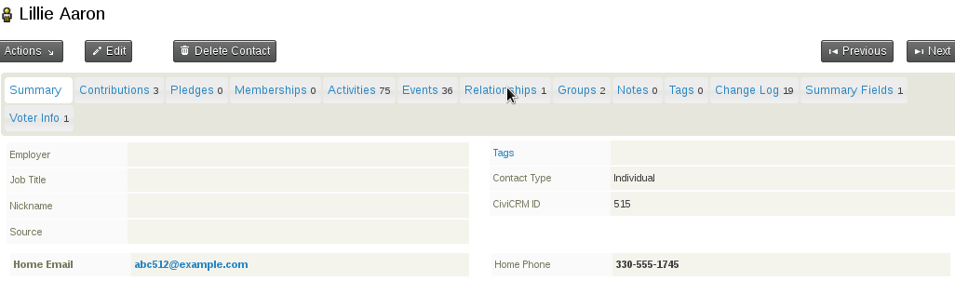
Clicking on this tab will show you the contacts current relationships and give you the option of adding a new one by pressing the Add Relationship tab.
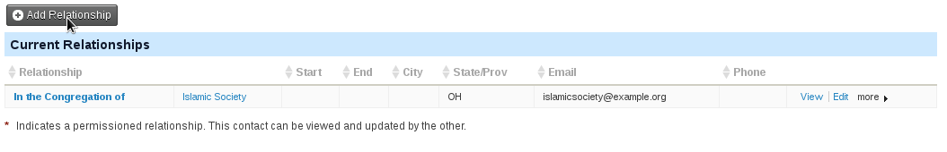

When adding a new relationship, first pick from the relationship type drop down. Then either start typing the name of a contact that already exists in your database, or create a new one.

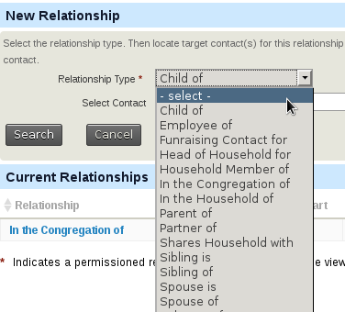
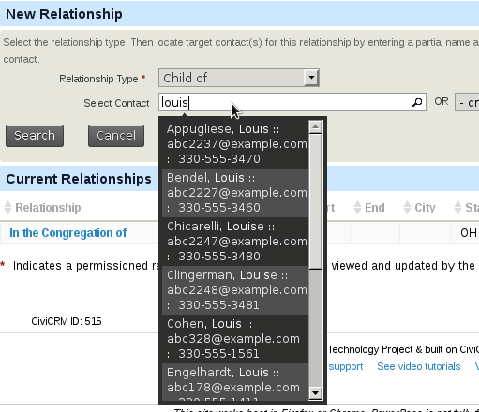
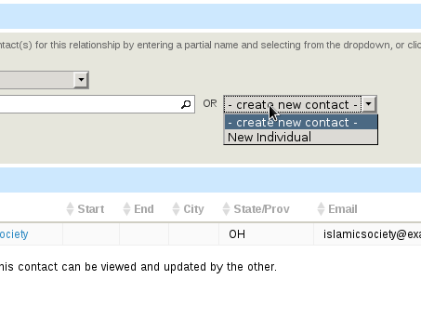

The last step is to fill in the details. You can optionally leave all fields empty.
The start and end date allow you to specify a time-restricted relationship (employment contract, etc.). If you allow contacts to login to your database, you may also specify that the relationship allows one person in the relationship to modify records of the related contacts.



