When a contact makes a contribution or attends an event or recieves an email (among other things), an activity record is automatically added the records this interaction.

Sometimes, however, we need to record other activities not automatically added, such as a phone call.

The first step is to find the contact you want to modify and then click the Activity tab.

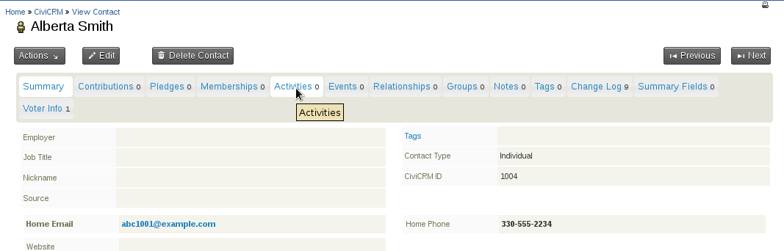
Next, choose the activity type you want to add from the drop down list.
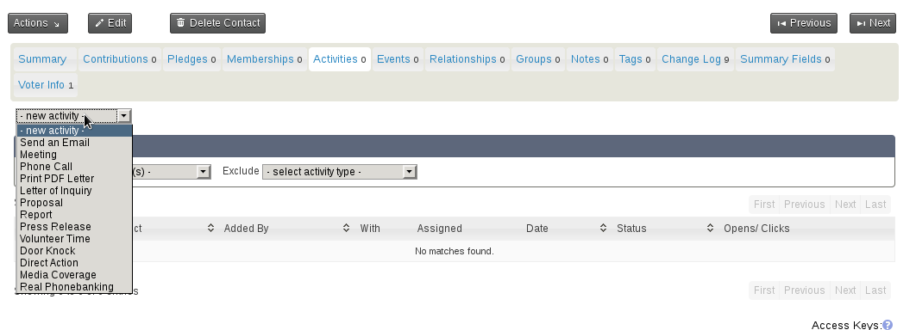
Lastly, fill out the details and click Save.


