This sheet accompanies TechCamp Online: Excel 2008 Beyond the Basics for Mac users. This contains step-by-step instructions for the skills we covered in the online training.
Contents
Understanding Clean Data 1
Quick Fixes 2
Substitute Formula 2
Find & Replace 2
Review of filtering/sorting 2
Filtering 2
Sorting 3
Splitting Apart (or Parsing) Data 3
Text to Columns 3
Merging Data 4
Concatenate 4
“No name” Ampersand Formula 5
Formulas 5
If Formula 5
DATEDIF formula 5
Paste Special 6
Creating a Chart / Graph 6
Pivot Table 6

Understanding Clean Data
Data has to be “clean” and accurate to be useful. Clean mostly means consistent.
Taking the accompanying spreadsheet, Practice File for Intermediate Excel, if we want to narrow our data down to get information about everyone in Washington, Texas, or everyone who paid a Full event fee, we can only do this if we give Excel consistent, correctly spelled and formatted data to manipulate.
“Dirty” data is missing info, is incorrect, or inconsistent – for example, when there are two spellings of a word, e.g. Bklyn vs. Brooklyn.

Spreadsheets & databases are not intelligent. Excel can’t know that Bklyn and Brooklyn refer to the same thing – and they really shouldn’t since they’re two different words. The data is only as good as the person’s attention is who enters it.
Look at data in Event Data and point out problem areas that are “dirty” – city, state, address.

Quick Fixes

Substitute Formula
Use the Substitute function to replace “Bklyn” with “Brooklyn”.
- Insert a column after the City State column.
- In cell to right of cell with “Bklyn” in it, type =SUBSTITUTE(E3, "Bklyn","Brooklyn") and hit Enter.
- Copy the formula to remaining cells, select cell with formula in it and click the lower right-hand corner of the black outlining and drag to bottom of column. If it’s a long column, you can also double-click that corner and the formula will be applied to rest of column.

Find & Replace
Find and replace does the same thing, but there is no need for a formula.

In order to limit the danger of using Replace, I always highlight the specific area of the spreadsheet to restrict the action to. Select the City column. Choose Edit, and click Replace. In Find, type Bklyn. In Replace, type Brooklyn. All strings found that match ‘Bklyn’ will be replaced with the new string.

For both this and Find & Replace, you have to be VERY careful. +z or Command+z for mistakes made!

Review of filtering/sorting

Filtering
Filtering is a way of narrowing down the data you’re looking at. An example is that you want to see only event attendees from Houston.
Click any cell in the document – no need to select anything.
Click Data > Autofilter to be able to apply a filter to any column in your spreadsheet. In the City column, click the arrow that appeared in the heading cell and you’ll see a dropdown of all the values in the menu. Click Houston. All records with other values in that column disappear (but don’t worry, they’re just hidden, not deleted).
When a filter has been applied, the arrow turns blue.
To remove the filter, click the arrow again in the header of that column and select Show All. If you have applied multiple filters, you can get rid of them all at once by returning to Data in the menu, and clicking Autofilter again, which deselects Autofilter.

Sorting
Sorting is useful to automatically order data.
Click Data > Sort…. Select Header Row under My data has at the bottom, and now under Sort by, select the column that you want to sort (i.e. City). Finally, decide whether the order should be ascending or descending.
If it’s text, it will be put in alpha order; if numbers, in numerical order.
You can sort further by choosing a column under Then by.

Splitting Apart (or Parsing) Data
When trying to keep data clean, it’s easier to have as little information as possible in each column. This is also true if you’re doing something like an import into a database.

So rather than having City and State in the same column, you might decide to break them into two columns (for example, so that sorting is easier). This is also true of addresses – you’ll need to split street number and street name into separate columns to create a walk list for GOTV efforts.

Text to Columns
- Insert column after City State column.
- Insert > Columns.
- Highlight the City State column.
- Click Data > Text to Columns.
- Follow the wizard through these steps.
- Select Delimited if the data you want to split up is divided by something consistent like a comma, space, or hyphen.
- Click Next.
- Click on the appropriate Delimiter (comma in this case).
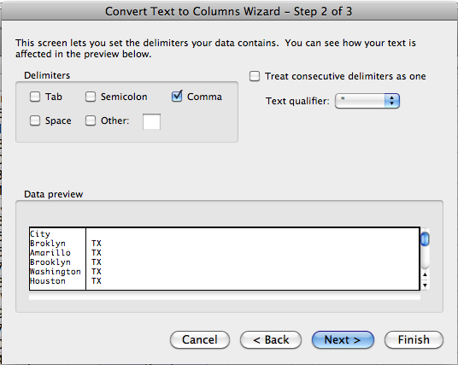
- Preview the data to make sure it works and click Next.
- Choose the data format for the columns that will result. Important note: choose Text for zip codes and phone numbers so Excel doesn’t treat them like numbers*.
- Click Finish.

*Otherwise, if a zip code has leading zero, the zero will be dropped after Text to Columns is applied. By default, Excel makes data type to General. Zip codes in the northeastern U.S. and many +4 digit zip codes start with zeros, and these zeros will be deleted unless you are careful about formatting cells to Text.

Merging Data
The opposite of parsing or splitting data apart is merging data.

Concatenate
Insert column after Last Name column.
Type =CONCATENATE(B2, “ “, C2) in a blank cell in your new column and hit Enter.
This should give you the contents of B2 and C2 with a space in the middle.
Double-click the lower right corner (known as the Fill Handle) of the cell you just typed the formula into to apply it to the entire column.

“No name” Ampersand Formula
Insert column after Last Name column.
Type =B2&” “&C2 in a blank cell in your new column and hit Enter. The ‘&’ between each of the items you want to put together acts as an unusual concatenate formula.

Formulas

If Formula
I want to do a targeted direct mailing to everyone over 55. I’ll need to divide the data into two groups – those older than 55 and those younger than 55.
Right now, if you used filter to do that, you would have to manually deselect all the ages that are younger than 55. Instead, I can use IF to say “if person is older than 55, put yes, if not, put no”.
- Insert column after Age in Voter Data spreadsheet (should be column Z). We’re going to apply a calculation to Age. This is why it’s important that age is treated like a number. Our if formula must follow this structure: =if(logical test, value if true, value if false).
- In second cell of new column (should be AA), type “=if(Z2 > 55, “Yes”, “No”). Note: Copying and pasting from this Word doc into Excel usually doesn’t work.
- Hit Enter.
- Double-click the lower right corner (known as the Fill Handle) of the cell you just typed the formula into to apply it to the entire column.
Note: 55 is being treated like a number, but ‘yes’ and ‘no’ are strings of text, so when we put strings in formulas, they always need quotations around them.
Now, you can easily filter the data for all of the people older than 55 by filtering for Yes. You could now copy and paste the results to a new document and do a mail merge to send your mailing just to those people.

DATEDIF formula
This formula is not covered in the recorded webinar.
Notice that the ages are out of date. What if we want this spreadsheet to stay up to date and calculate ages given today’s date? We could recalculate ages based on the date of birth (DOB) column. Make sure DOB column has cells formatted as DATE.
- Insert column after Age in Voter Data spreadsheet (should be column Z). This is going to be the Updated Age column.
- Type =DATEDIF(AB2, TODAY(), "Y") and hit Enter. Today() is just a formula on its own that results in whatever today’s date is. “Y” results in years. You could also use “M” or “D” for months or days.
- Double-click the lower right corner (known as the Fill Handle) of the cell you just typed the formula into to apply it to the entire column.
- Insert a blank column. Follow the steps in the If Formula section to accurately calculate age based on today’s date and the DOB column. Now you know who’s actually 55 today. Your spreadsheet will be up to date today, in a week, and in a year’s time as more people on the list fall into the over 55 category.

Paste Special

Paste Values
Paste Special allows you to pick and choose what you copy and paste in Excel. By default, you paste everything. You may instead want a cell to contain a value rather than the formula that results in that value. (I really want 4, not =SUM(2+2)).
To get values from formulas:
Highlight range of cells to copy.
Edit > Copy or on the keyboard, +c.
Click where you want to paste. Edit > Paste Special, click Values (rather than All).

Transpose
Switch to the Charts tab. Let’s say I get some new info about each of these demographic groups and I’d like to make a new chart where my headers (the boroughs of New York City) become the row headers. In other words, I want to preserve the order of the boroughs but make stack them vertically instead of horizontally.
- Click and drag to select the headers.
- Click Edit > Copy.
- Click a cell where you want your “stack” of row headings to start.
- Edit > Paste Special.
- Select Transpose at the bottom. Transpose makes a column paste as a row, or a row paste as a column.
- Click Ok.

Creating a Chart / Graph
Move to a the worksheet called Charts. In order to make a useful chart, your data has to be set up in a way that will make it easy to make a chart out of. Notice that we’ve set up the data on the Charts worksheet so that each column contains the percentages of each demographic group by borough in New York City. The chart we generate from this data will take the numbers and make them into a clear visual picture of the demographics.
- Click Charts immediately above the worksheet you’re in.
- Alternately, click Insert in the menu and select Charts.
- Highlight A1-A7 and drag across the percentages, including headings.
- Click the type of chart. Here, Bar is selected.
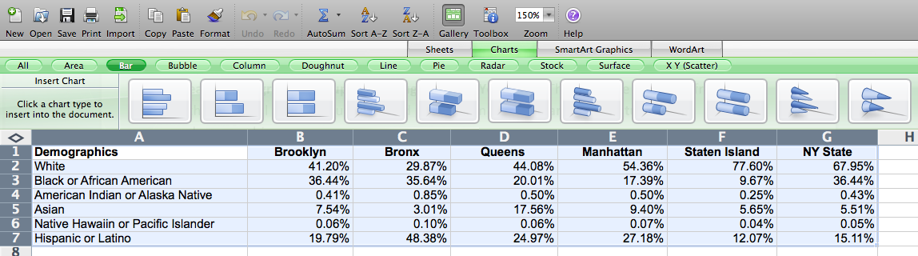
- Click on a bar chart that will make it easy to understand your data.
- Your chart will appear on your spreadsheet.
- Resize the chart if needed by clicking a corner and dragging to make bigger or smaller.

Pivot Table
Pivot Tables allow you to manipulate multiple subsets of information and analyze them.

Using the Voter Data worksheet, we want to see how many voters of a certain age voted in which precinct. This will give me a picture of voting by age and precinct that can lead to more questions about a door-knocking campaign that my organization wants to do.

Remove blank rows or columns. Check that all columns have headings. Format data type correctly.
- Highlight the entire table with column headings. Do this by clicking the upper left-hand diamond to the left of column A rather than by clicking and dragging.
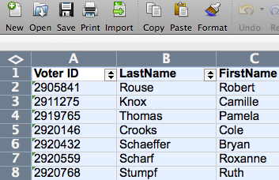

- Click Data > Pivot Table Report.
- By default, Excel recognizes your data range.
- Click Next.
- Also leave New Worksheet selected, and click Ok.
- Click Layout.
This is where you’ll set up what info goes into the chart from your data.
- Click Layout to see options based on the headings of your data.
- Now, you can make different sets of information show up in the chart by dragging headings from your highlighted spreadsheet to the image that represents your chart. In this box, you’ll place row labels, column labels, and values.
- Select Precinct Name and Age from the headings to the right, and drag them into ROW (We might even choose our Updated Age column that we created in the DATEDIF Formula section of this document).
- We’ll also select Party and drag it into Column.
- Take Party again and drag it into Data. This becomes COUNT of Party.
- Click Next and then Finish.

Notice on the pivot table you’ve created that you can see how many voted per precinct. You can also see how many voted by which party (Dems/Repubs/Independent).
We may want to go back to our list and do another sort/if formula to divide voters into a couple of groups by age. Then we could recreate our pivot table based on those age groups.
Our chart appears when we click Finish, as does a box with all the headings, in case you want to add more data to your chart. To make changes, just click and drag a category into (or out of) the row, column, or count areas of the pivot table from the pop-up that appears.
You also have at your command the drop-down filters that we saw during the first session.
- For example, you can use drop-down filters to view the data for only one precinct.
- Right-click on Sex, select “add to column labels” to see the sex of people from each party. Now, notice that the information is broken down further by sex.

