Where to Start: Building a Culture of Using Data Strategically
Excerpted and Revised from the PTP Data Needs Discovery Guide

Process Overview

Information (Data) flows through many different parts of an organization, so having a clear understanding of the data you have and don’t have is critical to determining if you’re meeting your organizational goals and strategies.

Including your whole organization, or at the very least key decision-makers or leaders in every area of your organization, in the process of understanding how data flows through your organization, is one of the most important steps in building a culture of using data and using it strategically.

This document focuses on leading groups through a process to determine your data needs and will help you begin to build a culture of data use.

The Discovery Process & Workflows

Determining the data needs of your organization is generally referred to as the discovery process. We can use this process to understand what data your organization has or needs and how this information flows through each area of your organization. You can describe how information or data moves through your organization using visual pictures and/or descriptive language called workflows.

Getting started: In order to move your organization to create a culture of data use and to make strategic decisions based on the information you’re gathering, it is going to require input and buy-in from the entire organization. To effectively manage your data, you will also want to make sure your database can support your work and help you track and analyze the data you’re gathering. Having all staff using the database will be a major indicator that your organization has been successful in creating the culture of use.

We recommend that a senior staff member act as the project manager shepherding the process along, and that there is also a database team or committee representing different areas of the organization involved throughout the entire process.

Process summary: PTP recommends that groups go through a process that includes the following steps to help you determine your data needs:

- Create a visual picture/map of a particular area of work and ask how you do that work. Eventually, you’ll want to do this for all areas of or the organization so that your organizational workflows are more integrated.
- Identify your strategies and tactics workflows.
- Review your map to make sure that the steps or processes are in the order that makes sense for efficiency and effectiveness
- Identify the data you are collecting and who is responsible
- Identify what the data is telling you and what are the gaps of information not being gathered. If you’ve mapped workflows for other areas of your organization, then overlay the workflows in each area of your organization and review the larger picture of data being gathered. Review the strategies and actions you’ve taken and compare to what the data is telling you or what the gaps are exposing. Ask if you need to collect other kinds of data, or change your strategies or work processes with what you’re learning from your data.
- Data and situations change over time, so periodically review your organizational questions and the working you’re trying to do and move through the process again and again and again…
- [For your database migration] Apply the workflows so that it maps the processes and data you need from the workflows with the processes and data you need to collect in your database for each department and/or function (for example organizing, fundraising, communications, administration…). Align the database to your organizational workflow needs.

All of these steps are highly iterative processes. You should expect to go through some of the steps more than once as you refine your understanding of your organization’s data needs.

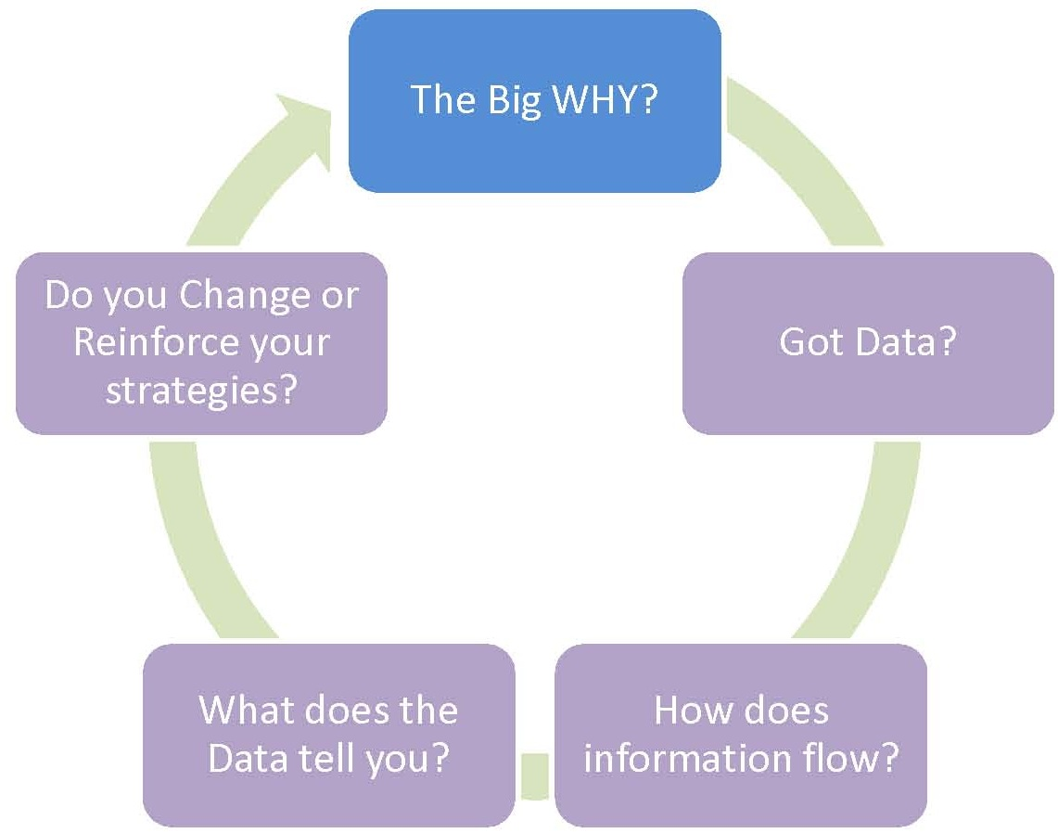

Building a Culture of Data Use

Visualizing your Organization’s model of Organizing, Communications, Fundraising and more

If your organization has not done so already, start by articulating your organizational goals and/or the goals of a particular area of work, project, or campaign. Next, document the model or process you go through to develop the strategies and tactics in that area. Repeat this process with every area of the organization to develop a complete visual map of your organization and its activities

With each area of your organization, ask ‘What are we trying to do? What is the purpose of our work?’:
- Example: Organizing -
  - Find a lead organizer/director to lead organizer discussion to lay out ‘what is their organizing model?’ ‘How do we move people through our organization?’ ‘How do we build leadership?’
  - Tell them to leave their thoughts BEHIND about how they do things in their existing database or spreadsheets, challenges with the old technology, etc. Instead, focus on the big picture – draw a map, a picture, a flowchart (this will essentially describe your organizational workflow) and ask: what is the vision, the goal of the organizing / basebuilding? What tactics or strategies or activities are you using to build your base, to mobilize people, to build leaders, etc.
  - Keep this map/picture visible so that you can always refer to it
- Have this discussion with each area of your organization: fundraising, membership, communications; map out a visual of the model of fundraising and communications – focusing on the organization interacts with people and how people engage with our organization
- Now look at the intersections of how each area of the organization ‘touches’ individuals – are strategies, tactics, activities shared between various areas of the organization to reach individuals? Do you rely on gathering the same information? Is information possibly duplicated?
- Is there information that you want to evaluate or analyze? How are you able to find out that information? Does a particular area of the organization potentially track information that would be useful for your strategy/activities with individuals?
- Update the maps / workflows / flowcharts with this updated information

Identify the Strategies and Tactics Workflows

For this next phase, you and/or your team will need detailed information about the organization’s workflows around strategies / tactics / activities. You will want to talk with key individuals in different areas of the organization to fill in these details.

- Talk about strategies / tactics / activities / campaigns – and talk about the work flow – how info moves thru your organization
- Stick to the discussion about ‘what do you really need to do?’ ‘What information do you I need to know about people, activities, etc.?’ What do I need to do with this information afterward? What do I need to evaluate, analyze the activity?
- Focus on the sequence of steps or processes. Do you see duplication of activity? Where can we be more efficient? Are we putting too much effort in one area that’s not really moving the strategy?
- This exercise will help you understand your organization’s work flow and information flow
- Map out / create a visual if possible or update the visuals you created earlier – most organizations don’t really map out workflows for strategies – but it is helpful to keep folks on the same page about the steps and be aware of information being gathered, updated, analyzed, used, along the way

Getting to the Specifics of the Data

In this next phase, you and/or your team will probably want to include a ‘techie’ to help you understand if your database is aligned or needs to be aligned with your data needs – someone who has knowledge about your existing technology infrastructure and can synthesize the information gathered from the earlier strategies / tactics workflow process and map these workflows along with the specific data you need to track for your database.

You need a working database to support your work and the data you need to inform your work.

Aligning the database with your workflows:
- Synthesize the information gathered in the workflow process into features / functions needed in the database to support the work – e.g. be able to track members met by particular staff
- Ask key staff who are most knowledgeable on the workflow process what pieces of information they currently use that is important for them, and that they need to have access to regularly; ask for information that is rarely used.
- Who will have access to the database? Ideally every individual in your organization should have access to the database.
- Ask them to explain WHY, and HOW they use it, and how/when they update the information. This process may also identify the pieces of information that really isn’t needed / or used at all
- This information can be used to start building the data dictionary or data map of their existing data and get an understanding of what it all means

Getting back to what the organization still needs:
- Now, go back to the overall vision, e.g. organizing map, and the strategies and workflows, and compare the information collected from key staff and look for gaps by overlaying the various workflows from the different areas of your organization. What other information or data do you still need? Do the gaps of information tell you anything new about your work?
- ID the gaps / needs; review the strategy, and work through what information do you need, what does the workflow look like; then work to figure out how the tool can support that workflow;
- Look for ways that the workflow can be streamlined where appropriate – sometimes workflows are created with unnecessary or way too many steps because individuals are using data system tools that are not effective or are broken

It Doesn’t End Here! The process is Reiterative.

Just because you may have a good database tool to manage your data, the work doesn’t end here – especially if you want your organization to be strategic in how it uses data.

As we know from our work, issues are ongoing and new ones arise, the context of our work and the questions we need to ask about what we need to do and the information we need to track changes over time. So that means we need to REVISIT the original questions about our work and take another look to see if we still have the data we need and see what data we don’t have. The information we’ve collected over time needs to be periodically scrutinized to see if the organizations strategies, tactics, and activities are still on track. Based on what you learn in reviewing the process again, your organization’s workflows, data and database needs may need to change to meet changes in your strategies.

